CHAPTER 6: BASIC OPTION STRATEGIES

END-OF-CHAPTER QUESTIONS AND PROBLEMS

1. (Buy a Put) The statement, “buying an at-the-money put has a greater return potential than buying an out-of-the-money put because it is more likely to be in-the-money” is wrong. If we replace the word “return” with the word “profit,” then the statement is correct. The lower the exercise price, the less likely a put option will be in-the-money at expiration, but it also has a lower price. This lower price results in magnified rates of return, hence the rate of return can be higher.

2. (Calls and Stock: The Covered Call) The covered call cuts losses on the downside and gains on the upside. In a bull market, the call is likely to be exercised and the stock called away. This limits the gain in a bull market to the amount of the premium plus the difference between the exercise price and the original stock price. A protective put cuts losses in a bear market but does allow gains in a bull market, which are higher the higher the stock price. Since a protective put is a synthetic call, the comparison is more appropriately seen as that of writing a covered call versus buying a call. Should we own stock and protect it with a short call or own simply the call? Both strategies are bullish, but the call (or protective put) would appeal more in situations where the investor is more concerned about taking advantage of a bull market than providing protection in a bear market.

3. (Calls and Stock: The Covered Call) You could concentrate on writing out-of-the-money calls; however, this would not guarantee that the stock would not be called away. The position must be carefully monitored. If the call moves in-the-money, it could be repurchased. Then you should write another out-of-the-money call. If the stock price continues to move upward, you continue to roll out of one exercise price into a higher exercise price. Disadvantages of this strategy are the potential for generating high transaction costs and the trouble of monitoring the portfolio, as well as the fact that writing out-of-the money calls produces relatively small premiums.

4. (Synthetic Puts and Calls) If P + S₀ – C < X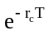, then the synthetic call (put plus stock) is underpriced or the actual call is overpriced. So buy the synthetic call and sell the actual call. The payoffs from this portfolio at expiration are

S_{T} ≤ X S_{T} > X
Short call 0 –(S_{T} – X)
Long stock S_{T} S_{T}
Long put X – S _{T} 0
X X

The cost of this portfolio is P + S₀ – C, which we said was less than the present value of the exercise price. So we are essentially buying a portfolio that pays off X dollars for certain and paying a price that is less than the present value of X.

5. (Calls and Stock: The Covered Call) N_{s} = –1 N_{c} = 1

Π = Max(0, S_{T} – X) – C – (S_{T} – S₀)

If S_{T} ≤ X, Π = – C – S_{T} + S₀

If S_{T} > X, Π = S_{T} – X – C – S_{T} + S₀ = S₀ – X – C

The breakeven is at a value of S_{T} ≤ X. Setting this profit equation to zero

–C – S_{T}* + S₀ = 0

and solving for S_{T}*

S_{T}* = S₀ – C

Maximum profit occurs if S_{T} = 0

Π = – C + S₀

Minimum profit occurs if S_{T} > X

Π = S₀ – X – C

which is negative since C must be greater than S₀ – X.

6. (Puts and Stock: The Protective Put)

N_{s} = –1

N_{p} = –1

Π = –Max(0, X – S_{T}) + P – (S_{T} – S₀)

If S_{T} < X, Π = – X + S_{T} + P – S_{T} + S₀ = P + S₀ – X

If S_{T} ≥ X, Π = P – S_{T} + S₀

The breakeven is at a value of S_{T} > X. Setting the profit equation to zero

P – S_{T}* + S₀ = 0

and solving for S_{T}*

S_{T}* = P + S₀

Maximum profit occurs at S_{T} < X

Π = P + S₀ – X

Minimum profit occurs if S_{T} = ∞

Π = –∞

7. (Calls and Stock: The Covered Call) Time value is directly related to time to expiration. If the covered writer closes out the position prior to expiration, the call will be more expensive to repurchase. This reduces the profit for a given stock price. The shorter the holding period, however, the less time the stock price has to move downward. Writers of options benefit from short holding periods by giving the stock less time to move, but they have to buy back more of the original time value they received.

8. (Calls and Stock: The Covered Call) The lower the exercise price, the more protection the option is providing. This is because the call with the lower exercise price commands a higher premium and the premium cushions the loss on the downside. The disadvantage of a lower exercise price is that the option is more likely to be exercised and the upside gain is lower.

9. (Stock, Call, and Put Option Transactions) Figure 6.15 in the text provides the summary of profit graphs for positions held to maturity. This question requires combining the long and short positions, highlighting the mirror image feature. First, the appropriate graphs should look something like the following:

Buy and Sell Calls
Buy Calls
$Profit

Stock Price at Expiration
$0

$Loss
Sell Calls
Strike Price

Buy and Sell Puts
$Profit
Sell Puts
Stock Price at Expiration
$0

Buy Puts

$Loss
Strike Price

Buy and Short Sell Stock
Buy Stock
$Profit

Stock Price at Expiration
$0

$Loss
Short Sell Stock

Notice that the short positions are just a mirror image of the long positions, where the mirror is held on the horizontal axis. Also, although not precisely correct, the call and put option graphs are mirror images of each other when the mirror is held vertically at the strike price. This will be precisely correct at the unique strike price where the call and put prices equal.

10. (Buy a Call) C = 5.25

Π = 100(Max(0,S_{T} – 165) – 5.25)

Option Value at
S_{T} Expiration Profit
150 0 –525
155 0 –525
160 0 –525
165 0 –525
170 5 –25
175 10 475
180 15 975

Note: If you use OptionStrategyAnalyzer10e.xlsm to generate the graphs in this chapter, the horizontal axis will be labeled as the “Stock Price at Expiration.” Here it has been changed to “Stock Price at End of Holding Period.”

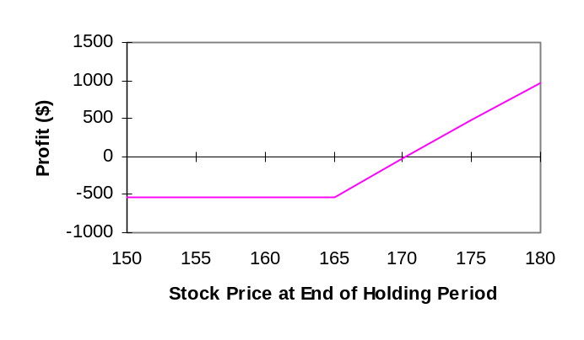

Breakeven: X + C = 165 + 5.25 = 170.25
Maximum loss: 525 (the premium)

11. (Buy a Call) X = 165 r_{c} = 0.0535 σ = 0.21

T – t = 20/365 = 0.0548 (based on 20 days between 8/1 and 8/21)

Plugging into the Black-Scholes-Merton model, we obtain the option values on August 1 for stock prices of 150, 155, … , 180.

Π = 100(Option Value on 8/1 – 5.25)

The results using a spreadsheet are

S_{t} Option Value on 8/21 Profit
150 0.0901 –515.99
155 0.4295 –482.05
160 1.4203 –382.97
165 3.4782 –177.18
170 6.7247 147.47
175 10.8992 564.92
180 15.5951 1,034.51

Note: If you use OptionStrategyAnalyzer10e.xlsm to generate the graphs in this chapter, the horizontal axis will be labeled as the “Stock Price at Expiration.” Here it has been changed to “Stock Price at End of Holding Period.”

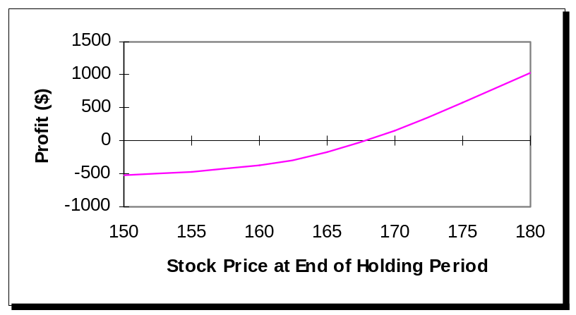

Approximate breakeven stock price: 168
Maximum loss: 525 (the premium)

12. (Buy a Put) P = 6.75

Π = 100[Max(0, 165 – S_{T}) – 6.75]

Option Value at
S_{T} Expiration Profit
150 15 825
155 10 325
160 5 –175
165 0 –675
170 0 –675
175 0 –675
180 0 –675

Note: If you use OptionStrategyAnalyzer10e.xlsm to generate the graphs in this chapter, the horizontal axis will be labeled as the “Stock Price at Expiration.” Here it has been changed to “Stock Price at End of Holding Period.”

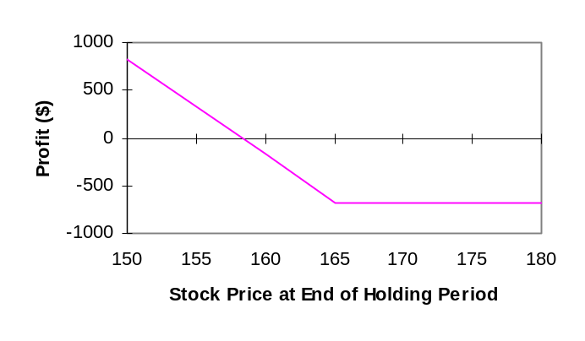

Breakeven: X – P = 165 – 6.75 = 158.25
Maximum loss: 675

Maximum gain (if S_{T} = 0): 15,825

13. (Calls and Stock: The Covered Call) C = 6

Π = 100(S_{T} – 165.13 – Max(0, S_{T} – 170) + 6)

Option Value Profit Profit Overall
S_{T} at Expiration from Option from Stock Profit
150 0 600 –1,513 –913
155 0 600 –1,013 –413
160 0 600 –513 87
165 0 600 –13 587
170 0 600 487 1,087
175 5 100 987 1,087
180 10 –400 1,487 1,087

Note: If you use OptionStrategyAnalyzer10e.xlsm to generate the graphs in this chapter, the horizontal axis will be labeled as the “Stock Price at Expiration.” Here it has been changed to “Stock Price at End of Holding Period.”

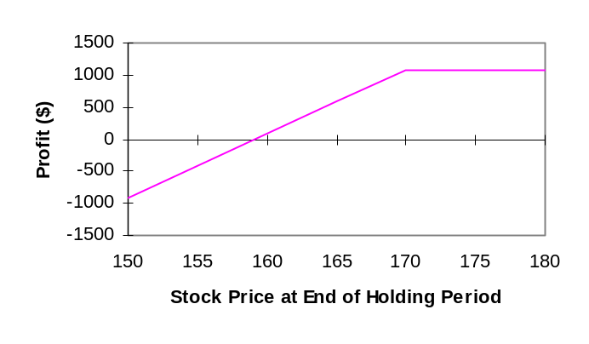

Breakeven: S₀ – C = 165.13 – 6 = 159.13
Maximum profit: 1,087
Maximum loss (if S_{T} = 0):
Profit from call = 600
Profit from stock = –16,513
Overall profit = –15,913 (maximum loss = $15,913)

14. (Calls and Stock: The Covered Call) X = 170 σ = 0.21 r_{c} = 0.0571

T – t = 45/365 = 0.1233 (based on 45 days from 9/1 to 10/16)

Plugging into the Black-Scholes-Merton model, we obtain the option values on August 1 for stock prices of 150, 155, … , 180.

Profit = 100[S_{t} – 165.13 – (Option Value on 9/1 – 6)]

The results using a spreadsheet are

Option Value Profit Profit Overall
S_{t} on 9/1 from Option from Stock Profit
150 0.2714 572.86 –1,513 –940.14
155 0.7297 527.03 –1,013 –485.97
160 1.6540 434.60 –513 –78.40
165 3.2381 276.19 –13 263.19
170 5.6014 39.86 487 526.86
175 8.7436 –274.36 987 712.64
180 12.5540 –655.40 1,487 831.60

Note: If you use OptionStrategyAnalyzer10e.xlsm to generate the graphs in this chapter, the horizontal axis will be labeled as the “Stock Price at Expiration.” Here it has been changed to “Stock Price at End of Holding Period.”

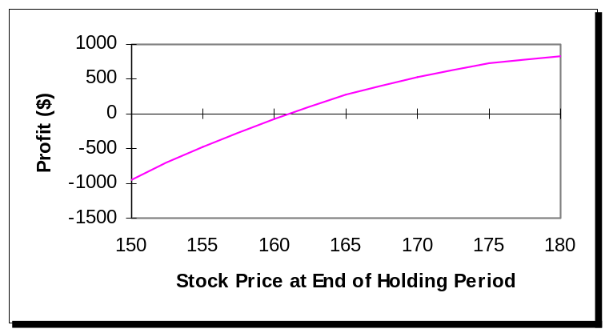

Approximate breakeven stock price: 162

15. (Puts and Stock: The Protective Put) P = 4.75

Π = 100[S_{T} – 165.13 + Max(0,165 – S_{T}) – 4.75]

Option Value at Profit Profit Overall
S_{T} Expiration from Put from Stock Profit
150 15 1,025 –1,513 –488
155 10 525 –1,013 –488
160 5 25 –513 –488
165 0 –475 –13 –488
170 0 –475 487 12
175 0 –475 987 512
180 0 –475 1,487 1,012

Note: If you use OptionStrategyAnalyzer10e.xlsm to generate the graphs in this chapter, the horizontal axis will be labeled as the “Stock Price at Expiration.” Here it has been changed to “Stock Price at End of Holding Period.”

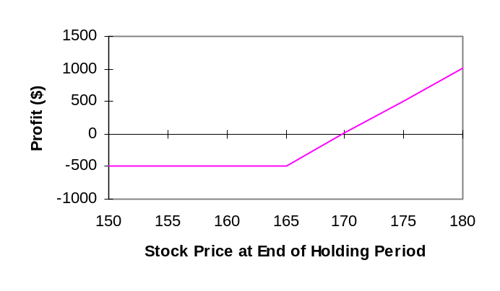

Breakeven: P + S₀ = 4.75 + 165.13 = 169.88
Maximum profit: ∞
Maximum loss: 487.50

16. (Buy a Call) C = $0.0385 X = $1.00
Contract size is €100,000
Premium is 100,000($0.0385) = $3,850

Option Value
S_{T} at Expiration Profit
$0.90 0.00 –$3,850
$0.95 0.00 –3,850
$1.00 0.00 –3,850
$1.05 0.05 1,150
$1.10 0.10 6,150

Note: If you use OptionStrategyAnalyzer10e.xlsm to generate the graphs in this chapter, the horizontal axis will be labeled as the “Stock Price at Expiration.” Here it has been changed to “Spot Exchange Rate at End of Holding Period.”

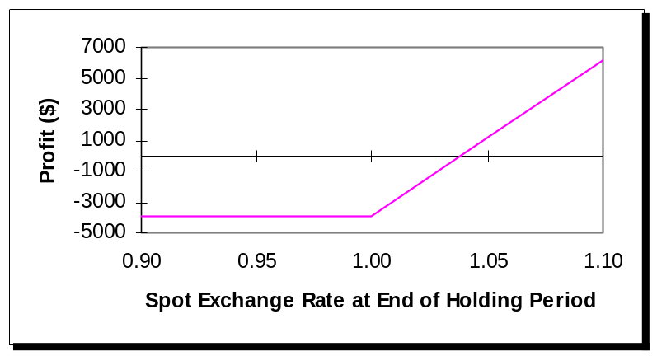

Breakeven exchange rate: X + C = $1.00 + $0.0385 = $1.0385

17. (Buy a Put) P = $0.0435 X = $1.00
Premium = 100,000($0.0435) = $4,350

Option Value
S_{T} at Expiration Profit
$0.90 0.10 $5,650
$0.95 0.05 650
$1.00 0.00 – 4,350
$1.05 0.00 – 4,350
$1.10 0.00 – 4,350

Note: If you use OptionStrategyAnalyzer10e.xlsm to generate the graphs in this chapter, the horizontal axis will be labeled as the “Stock Price at Expiration.” Here it has been changed to “Stock Price at End of Holding Period.”

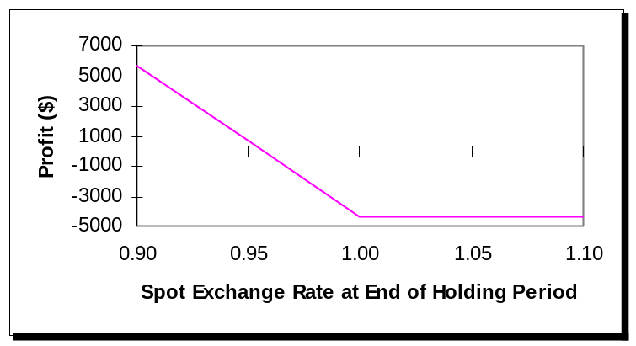

Breakeven exchange rate: X – P = $1.00 – $0.0435 = $0.9565

18. (Calls and Stock: The Covered Call) C = $0.0385 X = $1.00 S₀ = $0.9825
Contract size is €100,000
Premium is 100,000($0.0385) = $3,850
The currency costs 100,000($0.9825) = $98,250
Net cost = $98,250 – $3,850 = $94,400

Option Value
S_{T} at Expiration Profit
$0.90 0.00 –$4,400
$0.95 0.00 600
$1.00 0.00 5,600
$1.05 0.05 5,600
$1.10 0.10 5,600

Note: If you use OptionStrategyAnalyzer10e.xlsm to generate the graphs in this chapter, the horizontal axis will be labeled as the “Stock Price at Expiration.” Here it has been changed to “Stock Price at End of Holding Period.”

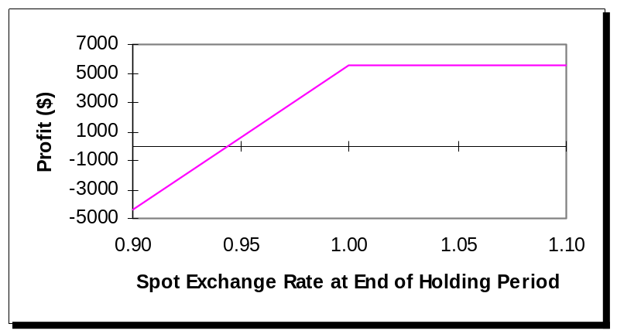

Breakeven exchange rate: S₀ – C = $0.9825 – $0.0385 = $0.9440

19. (Calls and Stock: The Covered Call) Covered call writing refers to owning the portfolio and writing call options. The key word to describe this strategy is ceiling, writing calls places a ceiling on the value of your portfolio. Covered call writing reduces the expected return and standard deviation of a portfolio as well as negative skewness. The following probability density function illustrates this strategy:

Probability

Change in Portfolio Value

20. (Puts and Stock: The Protective Put) Portfolio insurance with options involves owning the portfolio and buying put options. The key word to describe this strategy is floor, buying puts places a floor on the value of your portfolio. Protective put buying reduces the expected return and standard deviation of a portfolio as well as positive skewness. The following probability density function illustrates this strategy:

Probability

Terminal portfolio value

21. (Synthetic Puts and Calls) See excerpt from BlackScholesMertonBinomial10e.xlsm:

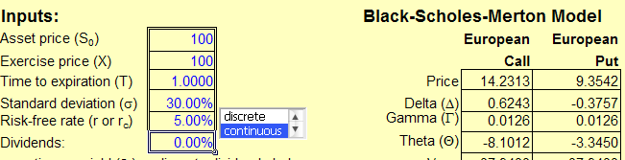

Synthetic call can be created by purchasing the stock and purchasing the put option. The cost would be $100 for the stock and $9.35 for the put. Thus, the most that would be lost is $9.35 that occurs if the stock price remains at or below $100. If the present value of the exercise price is borrowed, then the payoff will be identical to that of purchasing a call option.

22. (Synthetic Puts and Calls) Recall from put-call parity that

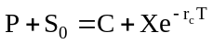

Solving for the stock price, we have

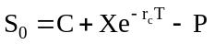

Synthetic stock can be created by purchasing the call and selling the put. The cost would be $14.20 less $9.30 or $4.90. The present value of the exercise price is $95.12. Thus, the cost of exactly replicating a stock is $100.02 (=$95.12 + $14.20 - $9.30). Assuming no transaction costs, if the stock price is $100, then you should buy the stock, sell the call, purchase the put, and lend the present value of the exercise price. This transaction would generate $0.02 today with no future liability.

23. (Synthetic Puts and Calls) This is a reverse conversion

Sell put +4.75
Buy synthetic put
Buy call –5.25
Sell stock +165.125
Net cash in 164.625

Invest at 5.35% to grow to 164.625(1.0535)^{0.1260} = 165.71

Amount owed at expiration = 165

Net gain = 0.71

24. (Buy a Call) a. Π = Max(0, S_{T} – X) – C – TC

where TC = transaction costs

S_{T} ≥ X
Π = S_{T} – X – 0.005X – 0.005S_{T} – C – 0.01C

S_{T} < X
Π = – C – 0.01C

(Buy a Put) b. Π = Max(0, X – S_{T}) – P – TC

S_{T} ≥ X
Π = – P – 0.01P

S_{T} < X
Π = X – S_{T} – 0.005X – 0.005S_{T} – P – 0.01P

(Calls and Stock) c. Π = S_{T} – S₀ – Max(0, S_{T} – X) + C – TC

S_{T} ≥ X
Π = X – S₀ + C – 0.005S₀ – 0.005X – 0.01C

S_{T} < X
Π = S_{T} – S₀ + C – 0.005S_{T} – 0.005 S₀ – 0.01C

(Puts and Stock) d. Π = S_{T} – S₀ + Max(0, X – S_{T}) – P – TC

S_{T} ≥ X
Π = S_{T} – S₀ – P – 0.005S_{T} – 0.005S₀ – 0.01P

S_{T} < X
Π = X – S₀ – P – 0.005X – 0.005S₀ – 0.01P

25. (Buy a Call) Denote with subscripts 1 and 2 for strike prices, call prices, profits, and rates of return based on two different strike prices where we assume X₂ > X₁. From the text, we know the dollar profit can be expressed as

Π₁ = [Max(0,S_{T} – X₁) – C₁]

Π₂ = [Max(0,S_{T} – X₂) – C₂]

From the boundary conditions in chapter 3, we also know

X₂ – X₁ > (X₂ – X₁)(1 + r)^{–T} ≥ C₁ – C₂ > 0 assuming T > 0 and r > 0

Thus, if both options are out-of-the-money, then the dollar loss for the lower strike price is greater than the dollar loss for the higher strike price because the lower strike call costs more as clearly seen in this Chapter 3 boundary condition. Also, if both options are in-the-money, then the dollar gain for the lower strike price is greater than the dollar gain for the higher strike price because of the boundary condition above and it is in-the-money sooner. Based on these insights, we can summarize with the following table:

Strategy | Long X₁ Call | Long X₂ Call | Relation
Profit (S_{T} < X₁) | –C₁ | –C₂ | Π₁ < Π₂
Profit (S_{T} > X₂) | S_{T} – X₁ – C₁ | S_{T} – X₂ – C₂ | Π₁ > Π₂
Profit (X₂ > S_{T} > X₁) | S_{T} – X₁ – C₁ | – C₂ | Π₁ Π₂

Thus, the profits are potentially equal only when X₂ > S_{T} > X₁ and specifically S_{T} – X₁ – C₁ = –C₂ or
S_{T} = X₁ + C₁ – C₂. This result can be graphically illustrated as follows:

$Profit

Stock Price at Expiration
$0

X₁ X₂
$Loss

S_{T} with same dollar loss

The result for rates of return is different, because the profits are divided by the initial investments. The rates of return can be expressed as

R₁ = Π₁/C₁ = [Max(0, S_{T} – X₁) – C₁] /C₁

R₂ = Π₂/C₂ = [Max(0, S_{T} – X₂) – C₂] /C₂

If both options are out-of-the-money, then the rates of return are both –100%. When only option 1 is in-the-money, then R₁ > R₂. Once option 2 is in-the-money, however, then at some high stock price the rate of return on the higher strike option will surpass the rate of return on the lower strike option due to its lower initial investment (more leverage). Thus, at some point above X₂ the two rates of return are identical. Solving for this terminal stock price, we find

R₁ = R₂

Π₁/C₁ = Π₂/C₂

[Max(0,S_{T} – X₁) – C₁] /C₁ = [Max(0,S_{T} – X₂) – C₂] /C₂

Because both options are in-the-money, we can drop the Max() symbol and solve for S_{T}:

[S_{T} – X₁ – C₁] /C₁ = [S_{T} – X₂ – C₂] /C₂

S_{T} = [C₁(X₂ – C₂) – C₂(X₁ – C₁)]/( C₁ – C₂)

The specific results are given below where S₀=$100, X=$100, r=5%, T=1 year, and σ=30%. The Black-Scholes-Merton option pricing model was used to generate the initial call prices.

Profit and Loss Diagram Rate of Return Diagram
